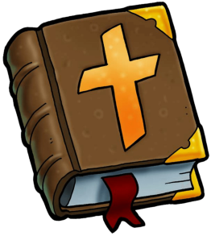

PRAYER

Do not feel embarrassed to request prayer from another Christian. Ask a believer who has repented and received Christ to pray. You can make your request explicit, or you can have an unmentioned prayer. Our Lord knows our needs. He knows all about us and everyone. You can ask a relative (who is born again), or the church, or the pastor for a powerful prayer.

The Holy Heavenly Father hears the prayers of a person who has made a decision to accept Christ. If we are living in sin or if we reject Christ, who died so that we can have a beautiful and right relationship with God. We need one another; we are the body of Christ. Be encouraged to ask for prayer so that you can be healed, in Jesus’ name.

**PLEASE JOIN US FOR WEEKLY PRAYER**

On Mondays, on Zoom at 6:30 p.m.

Answer to prayer, in Jesus’ name, is such a beautiful gift from our Heavenly Father. Know that Pastor Hagop and others would certainly be glad to lay hands on you and pray for your healing, as scripture tells us.

**Armenian Congregational Church, September 2024**

**ACC QUARTERLY**

**NEWSLETTER**

We are fortunate to have Reverend Pastor Hagop Haroutunian as our minister! He believes that the Word of God is truly inspired by the Holy Spirit, and that God speaks to us through His Word. We are very fortunate to have a church full of such lovely believers, who love God and love each other!

“Come make a joyful noise unto the Lord, and serve Him with gladness!”

**SCRIPTURES FOR SEPTEMBER**

“Not forsaking the assembling of

ourselves together” and *“exhorting*

*one another, even more as we*

*see the day* *of Christ’s return approaching.”*

*(*Hebrews 10:25) — before our Lord’s return*.*

Sunday — The Lord’s Day — is when the New

Testament Christians met and when we worship!

*“I was glad when they said to me, ‘Let us go into the house of the Lord!’”* (Psalm 122:1)

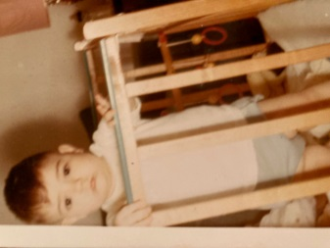

**CHEF FOR**

**SEPTEMBER**

**Cake Mars!** Super delicious and tender!

**Dough**:

5 eggs

7/8 cup sugar

1-1/2 Tbsp honey

6-1/3 Tbsp butter

1-1/2 Tbsp cocoa powder

1 tsp baking soda

1-1/2 cups of flour

**Preparation**: Mix eggs, sugar, cocoa, honey, butter. Put into a water bath (or low heat). Once oil has dissolved, add baking soda (without stopping to stir) - the mass will foam. Remove from the heat and add 1-1/2 cups of flour. Divide the dough into 3 or more parts. This may vary based on the size of your baking dish, but try to divide into equal parts. Then pour each part into a baking sheet, on the silicone mat, or parchment paper.

Bake at 375 degrees for 7-8 minutes.

**Cream**: 600 ml of very cold, heavy cream (33-35%)

Beat, starting at low speed, gradually increasing.

As soon as the mass begins to thicken a little, pour in 1 can of condensed milk in a thin stream. The mass thickens. Reduce the speed, add ¾ cup melted and already COOL dark chocolate. (Milk chocolate will work too) A very delicate chocolate cream!!

**Assemble**: layer with cream and chopped walnuts, or melted chocolate between layers is optional.

**Decorate**: decorate the cream with chopped walnuts or chopped (or melted) chocolate, melted caramel, or your preference.

**Nune Haroutunian**

our Pastor’s wife

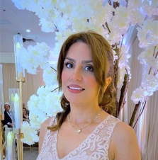

**WHO IS THIS?**

Guess who this good-looking guy is! He is in the choir and ministers to many! Tune in next time for the identity of this childhood/youth picture.

**BREAKFAST AND BIBLE STUDY:** Men and ladies meet on the first Saturday of each month at 10:00 a.m.

After breakfast, Rev. Hagop Haroutunian leads the men’s study, and Ann Bayleran leads the ladies.

*Forgiveness is such a beautiful expression of love.*

*Jealousy is a very unpleasant thing.*

*The greatest miracle is a changed life, when a person*

*repents and turns to follow Christ. This is truly being*

*born again.*

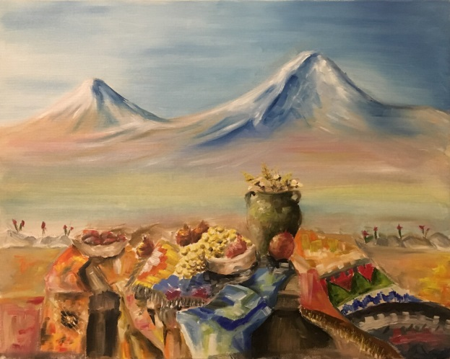

Email Susan Harrison in the church office:

office@accdetroit.org with your Armenian recipes or news to be included in the ACC Quarterly Newsletter. **Thank you+**

**YOUNG ADULTS**

Pastor Hagop is the leader of our Young Adult Fellowship and Bible Study. They meet bi-weekly for invigorating Bible study. They occasionally go on outings, enjoying various fun activities such as bowling, golf, and fellowship.

It is a fantastic group of young people. If you are in your teens through thirties, please see Pastor or Jacob Arslanian after church for any information to join!

**ARMENIA MISSION TRIP**

**FUNDRAISER**

Reverend Hagop and Nune will be going on a missionary trip to Armenia from September 15 to 27. They plan to visit and evangelize to several churches. You can make donations to those churches and their family members who have various needs, such as: church renovations, a sound system, A.C. unit, for the less fortunate, the sick, etc. Check donations can be made to the Armenian Congregational Church, and in the memo section, write: “Armenia Mission Trip.” Thank you for giving to this evangelical need!!

**JOIN CHOIR!!**

We would love to have more beautiful sounds soaring, to praise the Lord during our worship!! Speak with Susan after church, and rejoice in serving Christ’s church with your gifts!

**FRANCES GARABEDIAN** has given us “the gift of music” — an extraordinary amount of money to buy new music — **Thank you, Frances!!**

*Canon Of Thanks*

*With Empty Hearts We Wait*

*On This Shining Night (Christmas cantata book)*

*The Savior’s Lament*

*A Lenten Response*

*See The Bread And The Wine*

*A Classic Communion*

*Classic Alleluia Canon*

*Spirit, Come And Make Us One*

*Gracious Spirit, Holy Ghost*

*Do Not Be Afraid*

*In My Father’s House*

*There Is Room In My Father’s House*

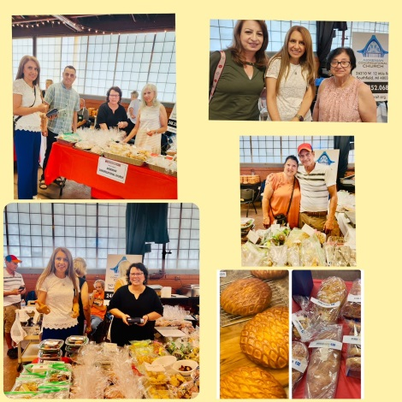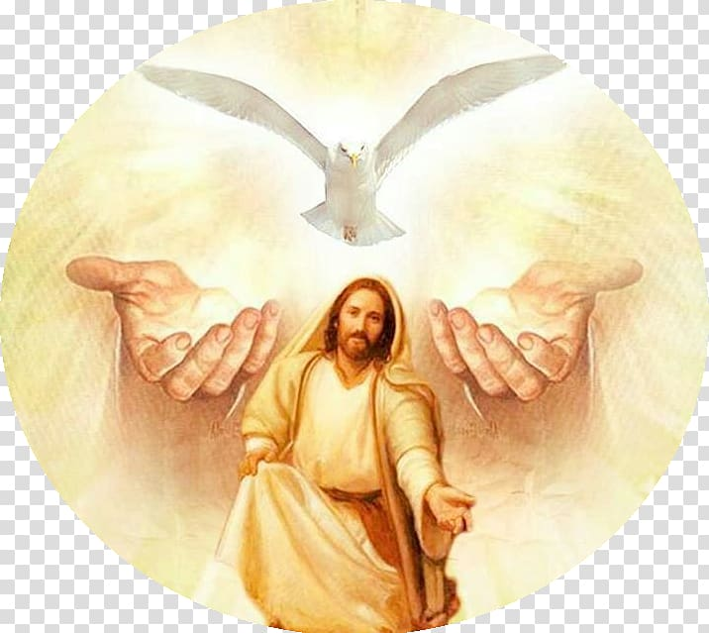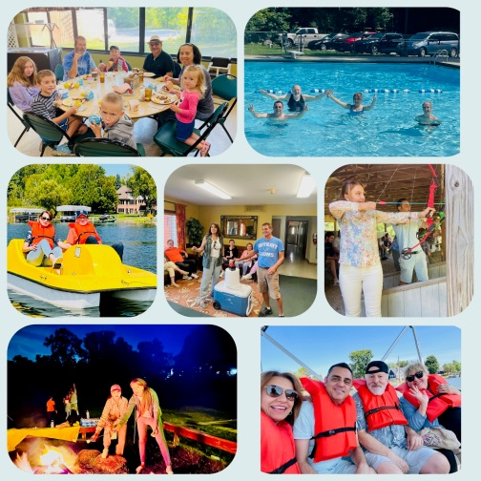

**THE BIBLE**

+ Is it history? — Yes

+ Is it lovely and inspirational? — Yes

• Does it show us how to be saved? Jesus is the Savior, and all who believe and receive Him will have eternal life.

• He who does not believe will be condemned.

+ Do you know? — The Bible is truly GOD’S WORD. And Jesus IS the Word. (John 1:1)

+ Revelation 19:13 calls Jesus’ name, The Word of God.

When Jesus returns to earth, Revelation tells us Jesus, Faithful and True, will ride a white horse. He will wear a vesture dipped in blood (representative of His sacrifice for all who believe, given for our forgiveness, to return us to God). He will have many crowns on His head. Jesus is the Creator. And on His robe is written a name:

KING OF KINGS! AND LORD OF LORDS!

**INSPIRATIONS**

**& MIRACLES**

Requesting your miracles

and inspirations to share.

Please respond by email to

Susan Harrison in the church office: Office@accdetroit.org

**ACC Past Events**

**ARMENIA FEST**

Every year in July, over a thousand people from the Armenian community of Detroit gather together from different churches and places to celebrate Armenian heritage — with Armenian music, dance, arts, food, and much more. Our church took part in doing bake sales to raise funds for our church. We had a wonderful time sharing Christ and our church with them.

**CHURCH RETREAT**

August 23-24 Our church was blessed to have a two day church retreat with guest speaker, Reverend George Dabbo, from the First

Armenian Evangelical Church of Montreal, Canada. We were blessed with a wonderful message, worship, games, food, and so much!!